|  |  |
| --- | --- |
| **NAME: CHANDA RICHARD CHIBWE**  **STUDENT ID: 201314010101**  **SCHOOL: INFORMATION & COMMUNICATION ENGINEERING**  **NATIONALITY: ZAMBIAN**  **COURSE: DIGITAL SIGNAL PROCESSING** |  |

**DISCUSS THE RELATIONSHIP AMONGST FT, DTFT, DFT AND Z- TRANSFORM**

**Introduction:** When a signal varies with time, we are usually concerned not only with its magnitude but also with how it changes. Oscilloscopes, strip chart recorders and other analog recording devices enable us to make observations of the signal by continuously recording and displaying the measurement data in the time domain. When digital computers are utilized for this purpose, however, the magnitude of the signal is sampled only at fixed intervals of time with a complete loss of continuity between. For data acquired in this form, the mathematics of digital signal processing can be used to analyze the signal in both the time and frequency domains. That is, we cannot know how the magnitude of the signal varies with time, but also what the amplitudes of any oscillations were over a spectrum of frequencies.

Since signals can either in either continuous or discrete or both in the time or frequency domain, different Fourier transformation techniques exist to handle these different kinds of signals. These include Fourier Transform (FT), Discrete Time Fourier Transform (DTFT) and Discrete Fourier Transform. The DFT transforms a discrete time and periodic sequence into a discrete and periodic sequence in the frequency domain. The DTFT transforms a discrete time sequence into a periodic but continuous signal in the frequency domain. The Z-Transform generalizes the DTFT.

For a signal which is suitable for a certain kind of transformation, if it becomes necessary for another type of transformation to be made on it, the signal needs to be modified. For example, a continuous time periodic signal is transformed into the frequency domain with the Fourier Transform (FT). If it becomes necessary for DTFT to be used, the signal must be converted to a discrete sequence by using sampling and other analogue - to – digital conversion techniques. Despite the fact that the different transforms operate on different types of signals, there exist some relationships amongst them. The rest of the journal discusses the different transforms mentioned previously, and the relationships that exist amongst them.

**Signal Transforms and the Relationships Existing amongst them**

The French mathematician, Joseph Fourier, found that any periodic waveform, can be expressed as a series of harmonically related sinusoids. In other words, sinusoids whose frequencies are multiples of a fundamental frequency (or first harmonic). In general, any periodic waveform, can be expressed as.

In exponential form. 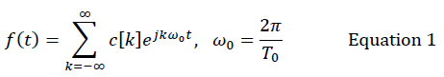

The complex coefficients, are represented as;

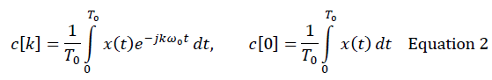

The Fourier series representation of periodic signals therefore consists of harmonically related sinusoidal signals with a discrete spectra, where the spectral lines are spaced at integer multiples of the fundamental frequency.

Fourier series representation of periodic signals can be extended to aperiodic signals by assuming that the aperiodic signal is periodic with an infinite period. Considering a discrete spectra of a periodic signal with a period of , as the period  increases, the fundamental frequency decreases, and successive spectral lines become more closely spaced. In the limit, as the period tends to infinity (i.e. as the signal becomes non-periodic) the discrete spectral lines merge and form a continuous spectrum. The Fourier equations for a continuous time, non-periodic signal, known as the Fourier transform (FT), and its inverse, are given byandrespectively as shown in equation 3 below.

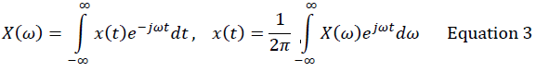

The integral shows that the frequency spectrum of a non-periodic signal is a continuous function of frequency.

In many applications, engineers desire to exploit the advantages of digital signal processing. However, many signals occurring in nature are analogue. To convert these signals to discrete forms, they are sampled at discrete time intervals. When the sampling is done in the time domain, but not in the frequency domain, Discrete Time Fourier Transform (DTFT) is used in the analysis of the signal. Consider a continuous-time signal,. This may be converted to a discrete time signal, by sampling at a period. Therefore, in the time domain, instead of a continuous time signal, which is a function of continuous time, there is a discrete version of that signalwhich are related to each other thus; ,  . The equation for DTFT, and its inverse, are shown in Equations 4 and 5 respectively. The DTFT of a signal is a continuous and periodic function of, with period.

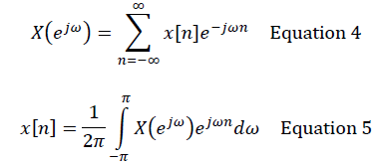

From the DTFT equations (Equations 4 and 5), it can also be observed that, even though the signal is discrete in the time domain, it is still continuous in the frequency domain. Therefore, computers cannot be used to process such signals. For that to be possible, the signal must be discrete in both the time and frequency domains.

To make it possible for computers to process signals, the signals are made discrete in both the time and frequency domains. Discrete Fourier Transform (DFT) is used in the processing of such signals. For a finite length sequence, a relationship exists between the DTFT and the DFT of a sequence. By takinguniformly spaced frequency samples of, we have . We can then have the DFT of the sequence as,

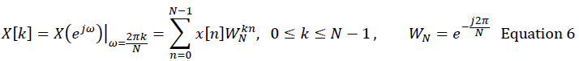

The inverse is also given by:

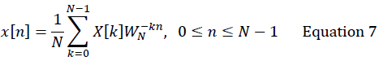

Consider the following equations, 8 and 9. Equation 8 is the DTFT of the sequence, whilst equation 9 is the inverse DTFT.

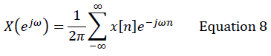

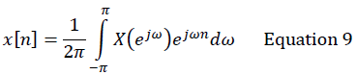

Assuming a periodic sequence whose - point DFT is given by , the DFT pair is given as;

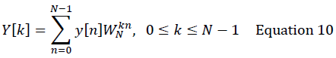

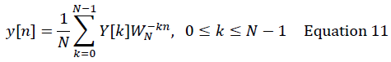

Being a periodic sequence, let the Fourier series representation of  be given as;

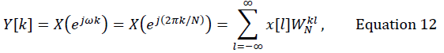

From the definition of the Fourier series coefficients in Equation 2, it can be observed that, being the Fourier series coefficients of , in Equation 12, have a relationship with the inverse DTFT of, in Equation 9. It can be seen that they are the same. Substituting equations 10 and 11 into 12, we get the following equation;

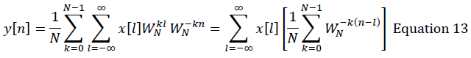

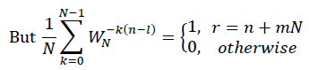

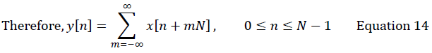

It can be seen from Equation 14 that, whereas in the time domain, a DTFT transforms an aperiodic sequence into the frequency domain, DFT makes that sequence periodic by adding an infinite number of shifted replicas of that signal and transforms it into a discrete and periodic sequence in the frequency domain.

From the definition of DTFT, it can be seen that the series may or may not converge. But the Fourier transform, of a sequence, exists, only if converges. For convergence to occur, the sequencemust be absolutely summable. That means,.

To deal with the convergence condition, the z-transform is defined as a generalised form of the DTFT. The z-transform of a sequence may therefore exist in situations where the DTFT of such signals do not exist. The equation defining the z-transform of a sequence is given by Equation 15.

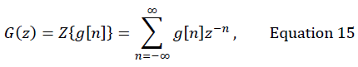

The variableis a complex variable. If , then it can be represented by Equation 16.

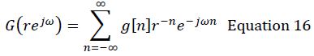

Equation 16 can be interpreted as the DTFT of the modified sequence, . It can be seen, in that case, that the DTFT of the actual signal, if it exists, is a special case of the z-transform where *r =1*. When *r = 1, |z| = 1* is a unit circle. That shows a relationship between the z-transform and the DTFT.

The z-transform of a sequence exists if it is absolutely summable. That is. For a given sequence *z*, the set of values of for which its z-transform converges is called the region of convergence (ROC). The DTFT, of a sequenceconverges uniformly if and only if the ROC of the z-transformof  includes the unit circle, hence, another relationship between the z-transform and the DTFT.

**CONCLUSION**

Transformations of signals are very important in signal processing. Therefore, many transforms exist for different kinds of signal analysis, and the hardware or software tools we seek to use for such analysis. In spite of the fact that there are many transforms, there exist some relationships among them. The relationships can be observed in both the time and frequency domains.

**References**

1. Mathews J. H. and Howell R. W. (2012), *Fourier Series,* Accessed 24th December, 2012. Available from http://math.fullerton.edu/mathews/c2003/FourierSeriesComplexMod.html.

2. Meddins B. (2000), *Introduction to Digital Signal Processing,* Newnes.

3. Mitra S. K. (2001), *Digital Signal Processing – A Computer-Based Approach,* 2nd Ed., McGraw-Hill.

4. Wikipedia (2012), *Discrete Time Fourier Transform,* Accessed 24th December, 2012. Available from http://en.wikipedia.org/wiki/DTFT.

5. Wikipedia (2012), *Discrete Fourier Transform,* Accessed 24th December, 2012. Available from http://en.wikipedia.org/wiki/Discrete_Fourier_transform.

6. Wikipedia (2012), *Z-Transform,* Accessed 24th December, 2012. Available from http://en.wikipedia.org/wiki/Z-transform.

7. Yarlagadda R. (2010), *Analog and Digital Signals and Systems,* Springer.